„Single Agent System Documentation”
Made by: Team 4
Team members
Purevdorj Usukhbay: d7eu3y
Al-Hitawi Mohammed: P622VN
E-mail:mohamedabid092@gmail.com

Nasir Mohammad Ausaaf
Course code: IPM-19fmiMASEG
Teacher’s name: Dr. Varga László Zsolt

2021. October 21.

Content
User documentation 3
Task 3
Runtime environment 4
Usage 4
Starting the program 4
Program input 4
Program output 5
Sample input and output 5
Possible errors 6
Developer documentation 7
Task 7
Specification 7
Developer environment 7
Source code 7
Solution 7
Program parameters 7
The structure of the program 8
Structure of functions 8
The algorithm of the program 8
The code 9
Testing 9
Valid test cases 9
Invalid test cases 9
Further development options 9

User documentation

Task
The scenario consists of single agent called (A)moving on a grid. The goal is to explore the world and acquire blocks to assemble them into complex patterns. This agent can attach things to each of their 4 sides. When the agent (A) move or rotate, the attached things move or rotate with them. The agent can connect things that are attached to it to create more complex structures.

Environment
The environment is a map girds. The dimensions are not known to the agent. Agent only perceive positions relative to their own. The x-axis goes from left to right (or eastwards) and the y-axis from top to bottom (southwards). The grid loops horizontally and vertically, i.e. if an agent moved off the right edge of the map, it will appear on the left side instead. Each cell of the grid contains up to one thing that may collide with other things (i.e. agents and blocks for now). Only in the beginning of the simulation, an agent shares the same cell (to ensure fairness). Once one of the agent has moved,
Have: an agent in an environment
Agents: take actions depending on the state of the environment
Environment: change its state as result, and may reward the agent
Goal: maximize the expected reward
E.g. agent: +100 for winning, -100 for losing, +20 for taking the $ and -20 for losing your $
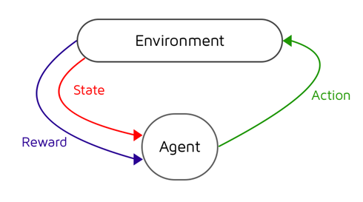

Runtime environment
A Computer that is capable of running python files, 64-bit operating system (e.g. Windows 10). Web browser, we have server side or backend (Implemented in java environment) and client side which is implemented in python. And it works on local server also can be work on online server.

Requirements tools
- Java on your machine
- Python
- IDE (Integrated Development Environment) Visual Studio Code

Starting the program
First we need to run the java files (Server side) after that the program can be found in the archived file by the name SingleAgentSystem\single_agent.py. You can start the program by executing the single_agent.py file.

Program input
The program reads the input data passed as JSON format from client side to the server side in the following order:
{: ['cw'],: 2,: ['something'],: 'rotate',: [{'x': 0, 'y': 0, 'details': 'A', 'type': 'entity'}],: ['b1', 'b2'],: True,: {'goal': [[-3, 1], [-2, 2], [-1, 3], [-3, 2], [-2, 3]]},: ['ccw'],: [],: 300}

# | Data | Explanation
 | lastActionParams
 | 'score'
 | 'task'
 | lastAction
 | things
 | attached
 | disabled
 | terrain
 | lastActionResult
 | tasks
 | energy
 | Goal
 | Dir

Program output
The program writes out beast path to achieve the Goal.by using depth first search algorithm .to find shortest path.

Sample input and output

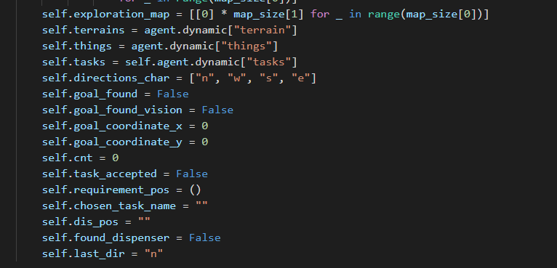
------------------------------------------------------------------------------------------------------------------------
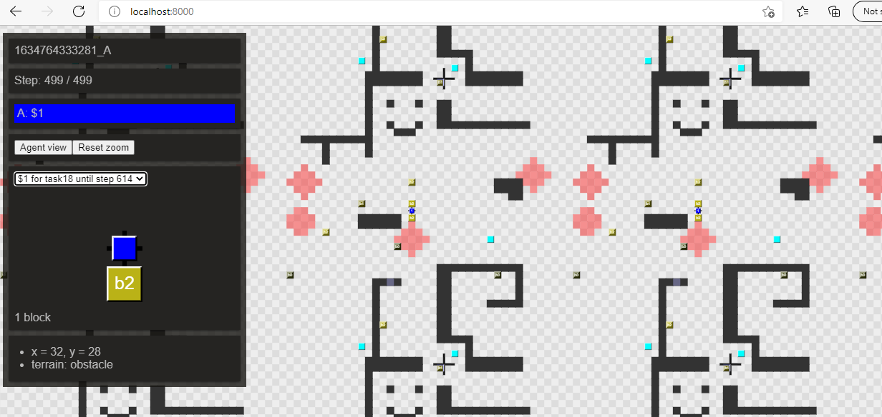

Possible errors
- The agent couldn’t accept the task.
- The goal is not beast path.

Sample of running in the case of invalid data:

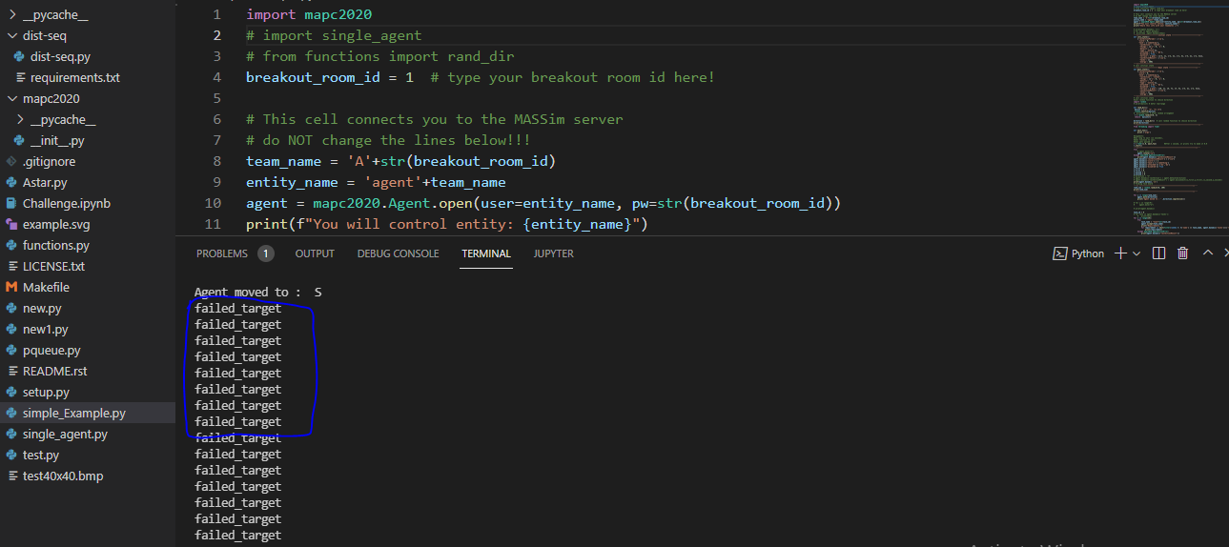

Developer documentation

Task
Agent should Accept the task and find the goal. And the agent should determine beast way.

Specification (Beast first Search Algorithm)
Input: JSON Format
Output: GUI Interface
Precondition: initial state (Agent should start from specific point) and accept the task
Post condition: goal state
.

Source code
All the sources can be found in the SingleAgentSystem folder (after extraction). The folder structure used for development:

File | Explanation
SingleAgentSystem\ __pycache__
SingleAgentSystem\ __pycache__\single_agent.cpython-39 | Executable code
SingleAgentSystem\ dist-seq\dist-seq.py | Python file
SingleAgentSystem\ dist-seq\ requirements | Txt file
SingleAgentSystem\mapc2020
SingleAgentSystem\mapc2020\__pycache__
SingleAgentSystem\mapc2020\__pycache__\__init__.cpython-39 | Initialization
SingleAgentSystem\single_agent.py | Python execution file
SingleAgentSystem\single agent _documentationteam4.pdf | documentation (current file)

Solution

Program parameters

Agent -→ A

The structure of the program
The modules used by the program, and their locations:
single_agent.py – the program, in the source folder
mapc2020 –
Main Program

Output result

Call functions

Models: random, intertools, operator

Structure of functions
Class Agent

Function Program
Search

The algorithm of the program
procedure preorder(treeNode v)
{
visit(v);
for each child u of v
preorder(u);
}
procedure dfs(vertex v)
{
visit(v);
for each neighbor u of v
if u is undiscovered
call dfs(u);
}
** the source (reference) is
https://www.techiedelight.com/depth-first-search/

The code
The content of the single_agent.py file: in the current zip file

Testing

Valid test cases

test cases

Localhost:8000 Agent Contest 2020

…

Further development options
- Data to be read from client
- Detection of errors
- Capability to run multiple times after each other
- Visual representation

Students in faculty of Informatics.

